OS PRACTICAL 1,2,3
- Terminal commands:-
uname:
lscpu:
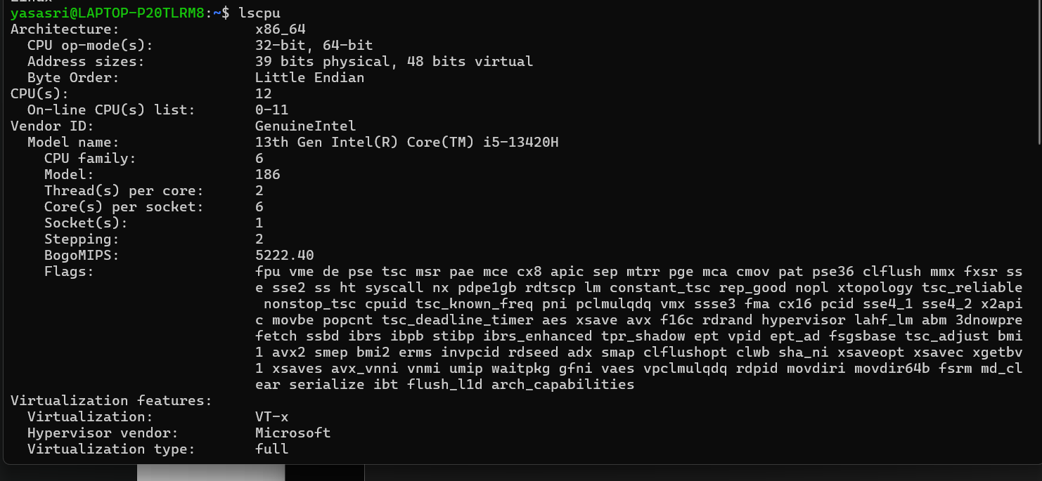
lsblk:
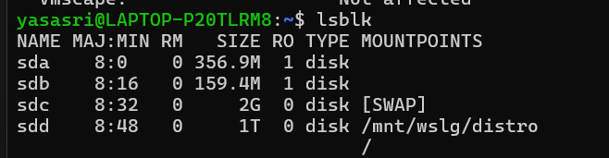
ps:
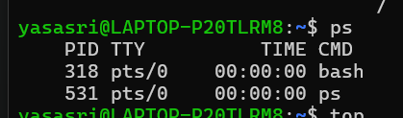

top:
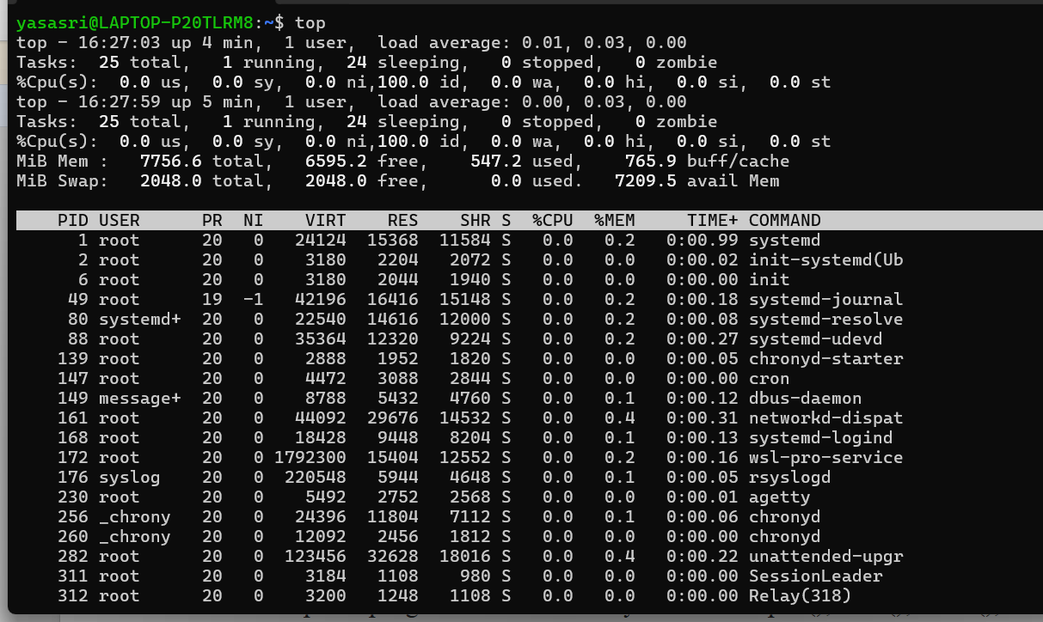

Command Purpose
uname Displays basic information about the operating system.
lscpu Displays detailed information about the CPU and its architecture.
lsblk Lists the available block devices such as hard disks and partitions.
ps Displays the currently running processes and their process IDs.
top Continuously displays running processes along with CPU and memory usage.

2)
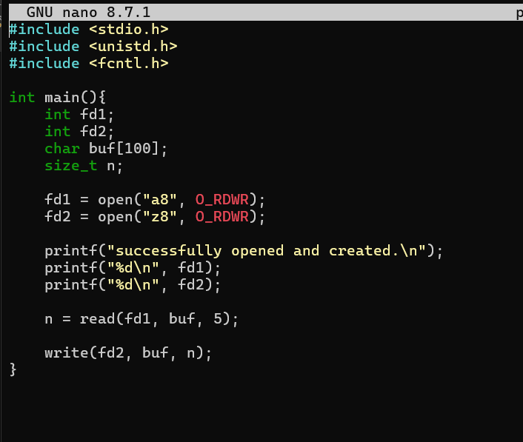

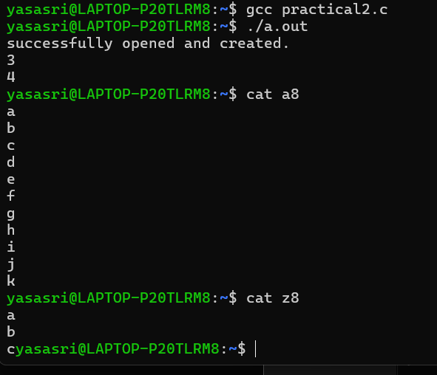

strace:
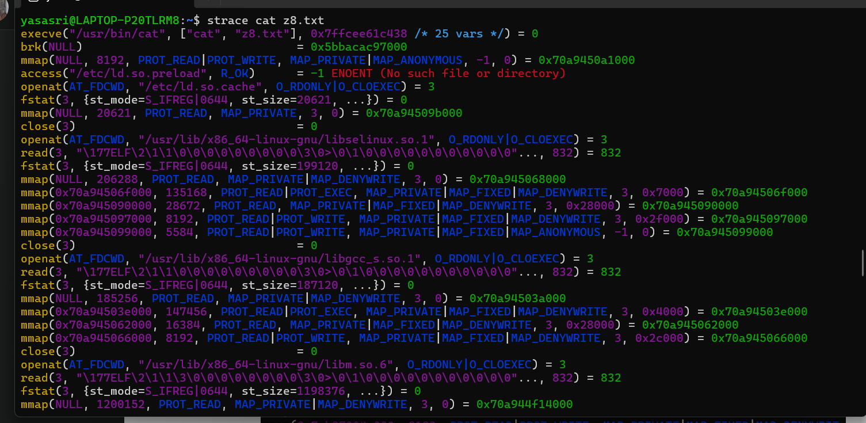

3)
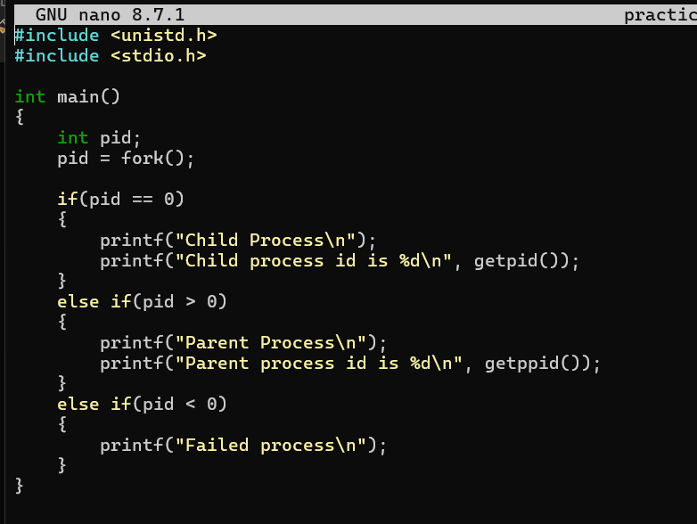

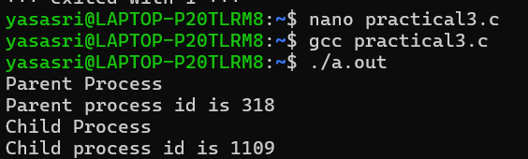

Experiment:
